Humanitarian project "Road alphabet"

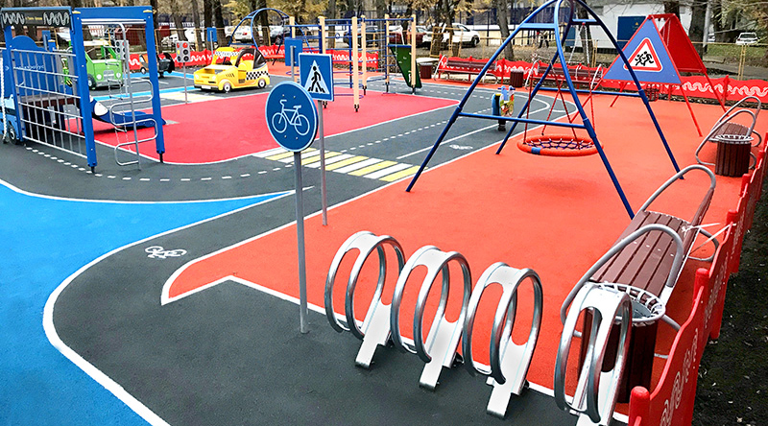

1. | Project title: | "Road alphabet"  universal children's training ground (car city) for practical classes on studying the rules of the road for preschool children among preschool educational institutions of the urban village of Zelva
2. | Name of the organization-applicant: | Department of Education of the Zelvensky District Executive Committee,  State Educational Institution "Preschool Child Development Center No. 1 of the urban village of Zelva"
3. | organization address, e-mail | Grodno region, Zelvensky district, Zelva urban settlement, Oktyabrskaya street, 15, tel. 80156472716,  e-mail: zelvacentr@mail.grodno.by
4. | information of organization | The department of education of the Zelvensky district executive committee ensures coordination of actions to organize the educational process in the region, create conditions for ensuring the quality of education  State educational institution "Preschool child development center No. 1 of the urban village of Zelva" - an institution of preschool education in which pupils of early and preschool age receive preschool education and rehabilitation, and also develop cognitive and creative abilities.
5. | Head of the organization | Zhebrak Svetlana Anatolyevna, head of the education department, 80156470361,  Mileshkevich Lyudmila Iosifovna, head of the State Educational Institution "Preschool Child Development Center No. 1 of the urban village of Zelva", 80156472716
6. | Рroject manager | Tatyana Ivanovna Karavaichik, Deputy Deputy Head for the main activities of the State Educational Institution "Preschool Child Development Center No. 1 of the urban village of Zelva", 80156472716
7. | Amount requested  in USD: | $ 40 000
8. | Co-financing  (own contribution) | $8 000
9. | Project dates: | 1 year
10. | Project goal: | Improving the level of safe behavior skills among preschool children of the urban village of Zelva and their parents by creating a playground «Road Alphabet», which will become a center that unites preschool children, parents, teams of young traffic inspectors for joint activities aimed at developing theoretical knowledge in children in practice using game technologies for teaching the rules of the road.
11. | Project objectives: | 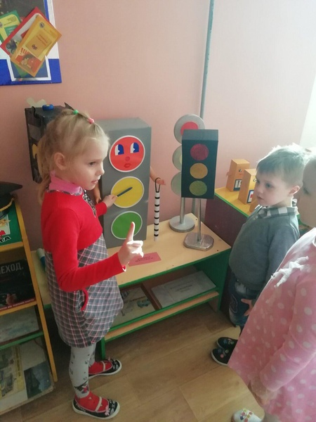  Arrangement of the playground "Azbuka bezopasnosti" for children of preschool age in the urban village of Zelva.  Ensuring the functioning of the playground "Azbuka bezopasnosti" for preschool children through thematic events (once a month) with the involvement of interested parties.
12. | Detailed description of project activities | The low level of safe street behavior skills among preschool children has caused an increase in road traffic accidents involving children in the Grodno region. According to the State Automobile Inspectorate of the Department of Internal Affairs for the Grodno region, for 7 months of 2021, 21 traffic accidents involving children were registered on the roads of the Grodno region. In these accidents, 17 children were injured, five died.  Reasons for these incidents: lack of knowledge and motives for safe behavior in children; lack of a developing environment for the formation of these skills; lack of a sufficient example of adult safe behavior.  A survey of the parent community of the Yuzhny microdistrict of the urban village of Zelva (82 families in which children of preschool age participated in the survey) showed that 75 families (90.4%) feel the need to create such a town for their children and are sure that it will to promote the formation and prevention of safe behavior skills in preschool children.  The creation of conditions for teaching preschool children the skills of safe behavior on the street and on the road will be used not only for small residents of one microdistrict, but will also provide an opportunity for preschool children of the urban village of Zelva to attend thematic events for the prevention of road traffic injuries among children.  Why "We?" Our institution is located in this microdistrict and we have a "District Safety Center" equipped, which contributes to the formation of fire safety skills in children. Our institution employs teachers of preschool education of the highest qualification category, who know the methodology of teaching preschool children. The methodological base of the institution is partially equipped with manuals and developments of educational materials on this issue  This project is an integral part of the curriculum of preschool education, in part, formed by the participants in the educational process in the direction of "Socio-moral and personal development" and contains the stages of the institution's activities to improve the conditions for the socio-moral development of children based on a system-activity approach, methodological recommendations for the use in educational activities with children of new elements of the content of education, new educational technologies, forms, methods and means of teaching, and taking into account the leading activities of a preschooler.  A playground is necessary to create a multi-level training for children of different ages from a theoretical level to practical road safety skills in a specialized play and learning space.  January-May - preparation of the territory for the installation of a universal training playground:  site preparation (cleaning the territory, leveling the soil);  installation of asphalt pavement;  drawing road markings;  installation of traffic lights and road signs.  June-August - site arrangement:  1. Pedestrian crossing  2. Road network with traffic signs  3. Parking - a hangar for children's bicycles  4. Layout "Hospital"  5. Layout "DPS"  6. Layout "Gas station"  7. Layout "Stop"  8. Forum (training ground) on the territory of the institution for gathering pupils and holding events  September - grand opening of the site. District holiday "Connoisseurs of the rules of the road"
13. | Activities after the end of the project | A designed training ground on the territory of the preschool center for conducting practical classes on teaching children the rules of the road;  organization of events, competitions, role-playing games, theoretical and practical classes with preschoolers of an urban village;  holding regional events "Road Mosaic", close to reality;  involvement in the activities of children of preschool and primary school age (as part of the continuity of education), parents, teachers, school organizations of young traffic inspectors, information services, inspectors of the state traffic safety inspectorate;  promotion of traffic rules, prevention of road safety in the children's environment, the parent community.

PHOTO 1 thematic stations on the site

