Humanitarian project of a healthcare institution
«Chervenskaya Central District Hospital»

«Living water»

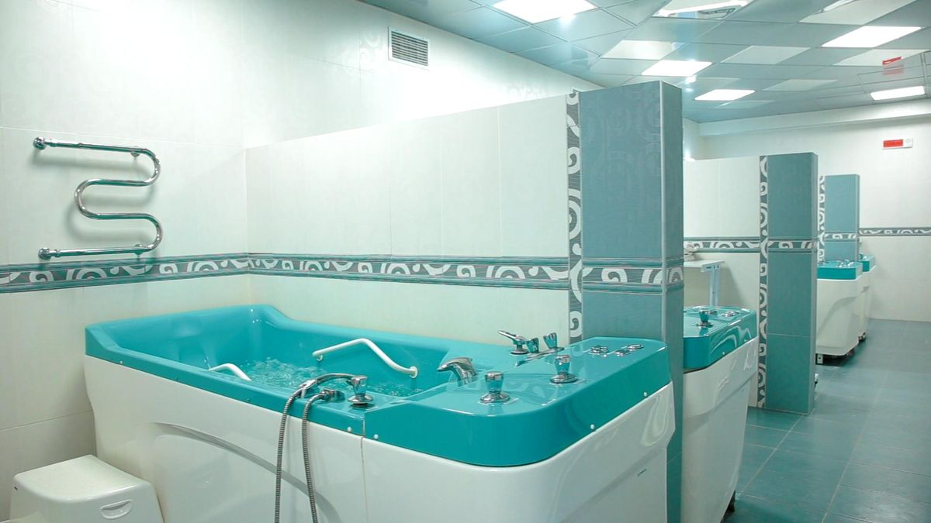

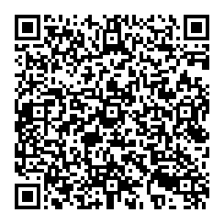

1. Project name: «Water of life»
2. The project implementation period: 2 years
3.Applicant organization proposing the project:UZ "Chervensky Central district hospital»
4.The objectives of the project: Create an enabling environment for the rehabilitation and preservation of people 's health, active lifestyles and improved quality of life.
5.Tasks to be carried out within the framework of the project:
- The preservation and promotion of the health of all segments of the population;
- Prevention of exacerbations and complications of chronic diseases in children and adults;
- Reduction of temporary incapacity for work and duration of patients stay in hospital;
- Comprehensive rehabilitation therapy in children (autism, cerebral palsy, mental illness) and adults;
- Reducing mortality and disability, improving the quality of life;
- Increase in life expectancy;
- Reconstruction of the diving room;
- Acquisition of special technical equipment;
6.Task Force: Population of Chervensky District
7.Project activities summary:
- Water treatment is a department for rehabilitation procedures using the therapeutic properties of fresh water, as well as artificially prepared mineral waters. Treatment bath procedures such as sodium chloride, iododromic, pantomagnium;
- Creation of conditions for professional development and development of specialists of the institution;
- Dissemination of information about the project through mass media;
- Exchange of experience with interested structures.
8.Total funding (United States dollars):60000
Financingsource | Amount of funding (United States dollars)
Meansofthedonor | 54000 US dollars
Co-funding | 6000 US dollars
9.Location of the project (region/district, city):Minsk region, Сherven, Barykin str. 60.
10. The expected effect is to improve the health of the population and the quality of life, reduce the duration of temporary incapacity to work, and reduce disability.
11.Contact person: Nadezhda Setsko, Legal Adviser, 801714 25993, office@chervenmed.by

