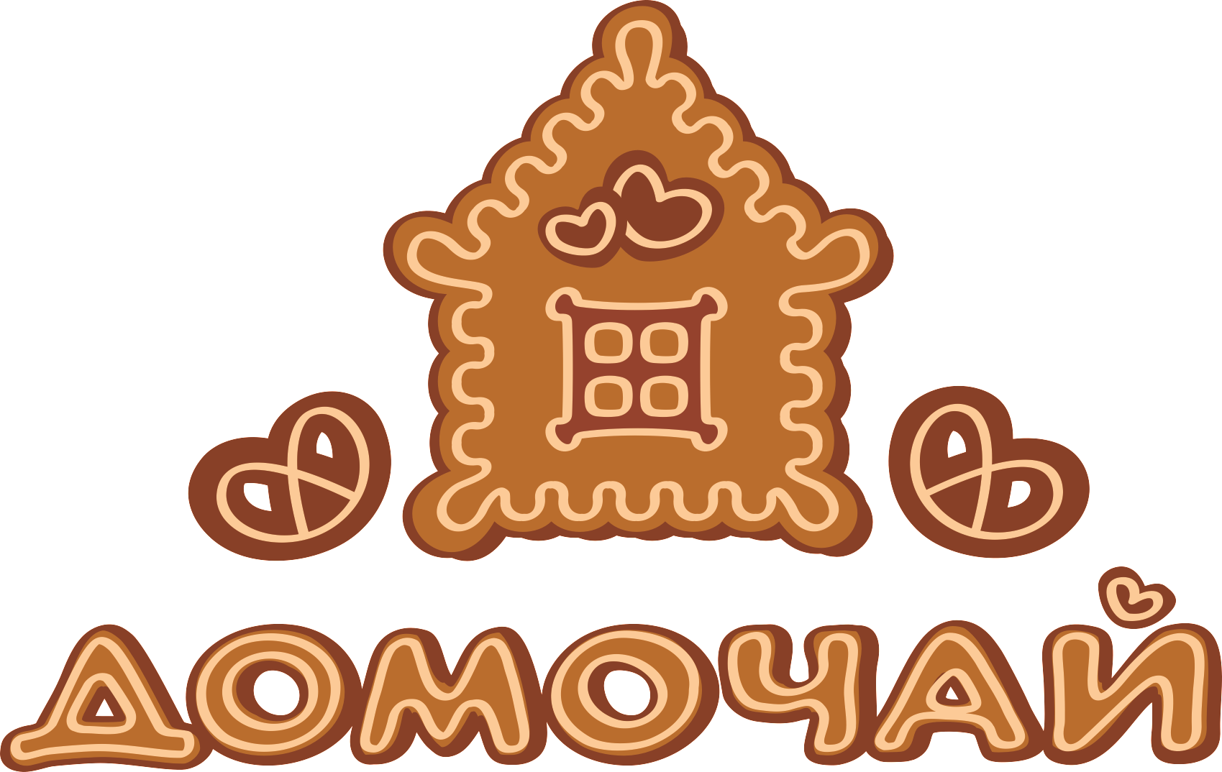
JSC “Bakery-confectionery company “Domochay”
(Frozen confectionery products)

Name | Net weight in a box/package, kg | Shelf life,  days | Picture | Description
Gingerbread  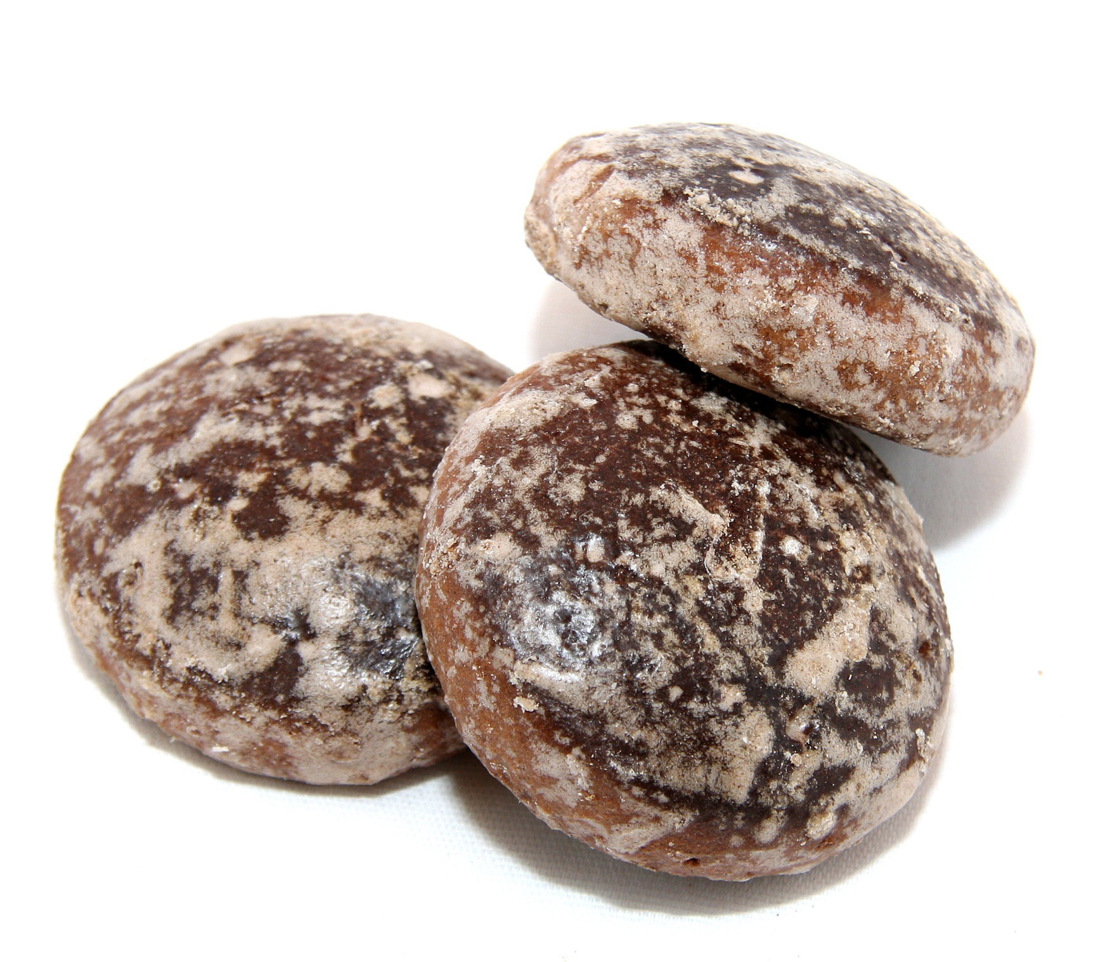  “Appetitnye” | 5,0 | 1 year | 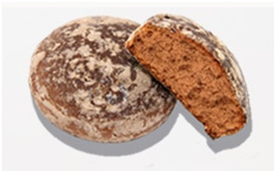 | Gingerbread is made of wheat flour with sugar, artificial honey, mélange, sunflower seed oil, cocoa powder, invert syrup, skimmed milk powder, ammonium bicarbonate, sodium bicarbonate, food additive «Sjurpriz -plus».
 | 0,4
Gingerbread  “Voronezhskie”  new | 5,0 | 1 year | 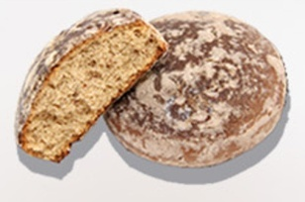 | Gingerbread is made of wheat flour with sugar, artificial honey, margarine, eggs, sunflower seed oil, ammonium bicarbonate, food additive «Sjurpriz -plus», sodium bicarbonate, Mint flavoring.
 | 0,4
Gingerbread  “Dneprovskie” glazed | 5,0 | 1 year | 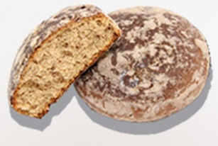 | Gingerbread is made of wheat flour with sugar, margarine, invert syrup, dry perfume, ammonium bicarbonate, sodium bicarbonate, complex food additive «Sjurpriz -plus».
 | 0,4
Gingerbread  “Dorozhnye” | 5,0 | 1 year | 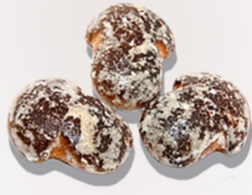 | Gingerbread is made of wheat flour with sugar, invert syrup, margarine, peanut crushed, skimmed milk powder, flavoring Peanut, ammonium bicarbonate, sodium bicarbonate, food additive «Sjurpriz -plus».
 | 0,4
Gingerbread  “Kluchiki” | 5,0 | 1 year | 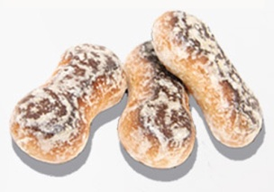 | Gingerbread is made of wheat flour with artificial honey, sugar, invert syrup, margarine, mélange, skimmed milk powder, flavoring Fruit and berries, ammonium bicarbonate, sodium bicarbonate, food additive «Sjurpriz -plus».
 | 0,4
Gingerbread  “Limonchik” | 5,0 | 1 year | 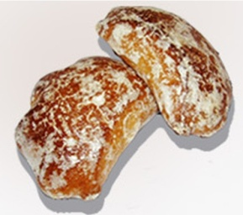 | Gingerbread is made of wheat flour with artificial honey, sugar, margarine, flavoring Lemon, ammonium bicarbonate, sodium bicarbonate, food additive «Sjurpriz -plus».
 | 0,4
Gingerbread  “Lesnye” | 5,0 | 1 year | 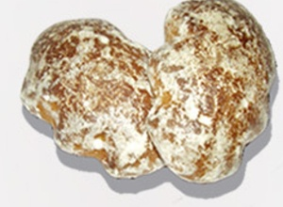 | Gingerbread is made of mixture of wheat flour and rye flour with sugar, margarine, invert syrup, kvass wort concentrate, melange, ammonium bicarbonate, sodium bicarbonate, food additive «Sjurpriz -plus».
 | 0,4

Gingerbread  “Medoviki” | 5,0 | 1 year | 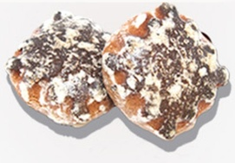 | Gingerbread is made of wheat flour with artificial honey, sugar, margarine, eggs, ammonium bicarbonate, sodium bicarbonate, food additive «Sjurpriz -plus».
 | 0,4
Gingerbread  “Ranitsa” | 5,0 | 1 year | 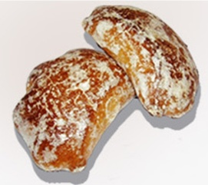 | Gingerbread is made of a mix of wheat flour and oat flour with sugar, invert syrup, margarine, skimmed milk powder, cocoa powder, ammonium bicarbonate, sodium bicarbonate, flavoring Rum, food additive «Sjurpriz -plus».
 | 0,4
Gingerbread  “Uralskie” | 5,0 | 1 year | 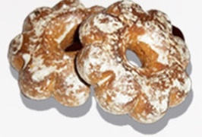 | Gingerbread is made of wheat flour with sugar, artificial honey, margarine, mélange, ammonium bicarbonate, food additive «Sjurpriz -plus», sodium bicarbonate, flavoring Fruit and berries.
 | 0,4
Gingerbread  “Figurnye” glazed | 5,0 | 1 year | 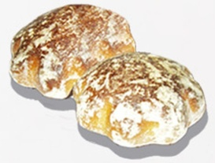 | Gingerbread is made of wheat flour with sugar, invert syrup, mélange, dry perfume, ammonium bicarbonate, sodium bicarbonate, food additive «Sjurpriz -plus».
 | 0,4
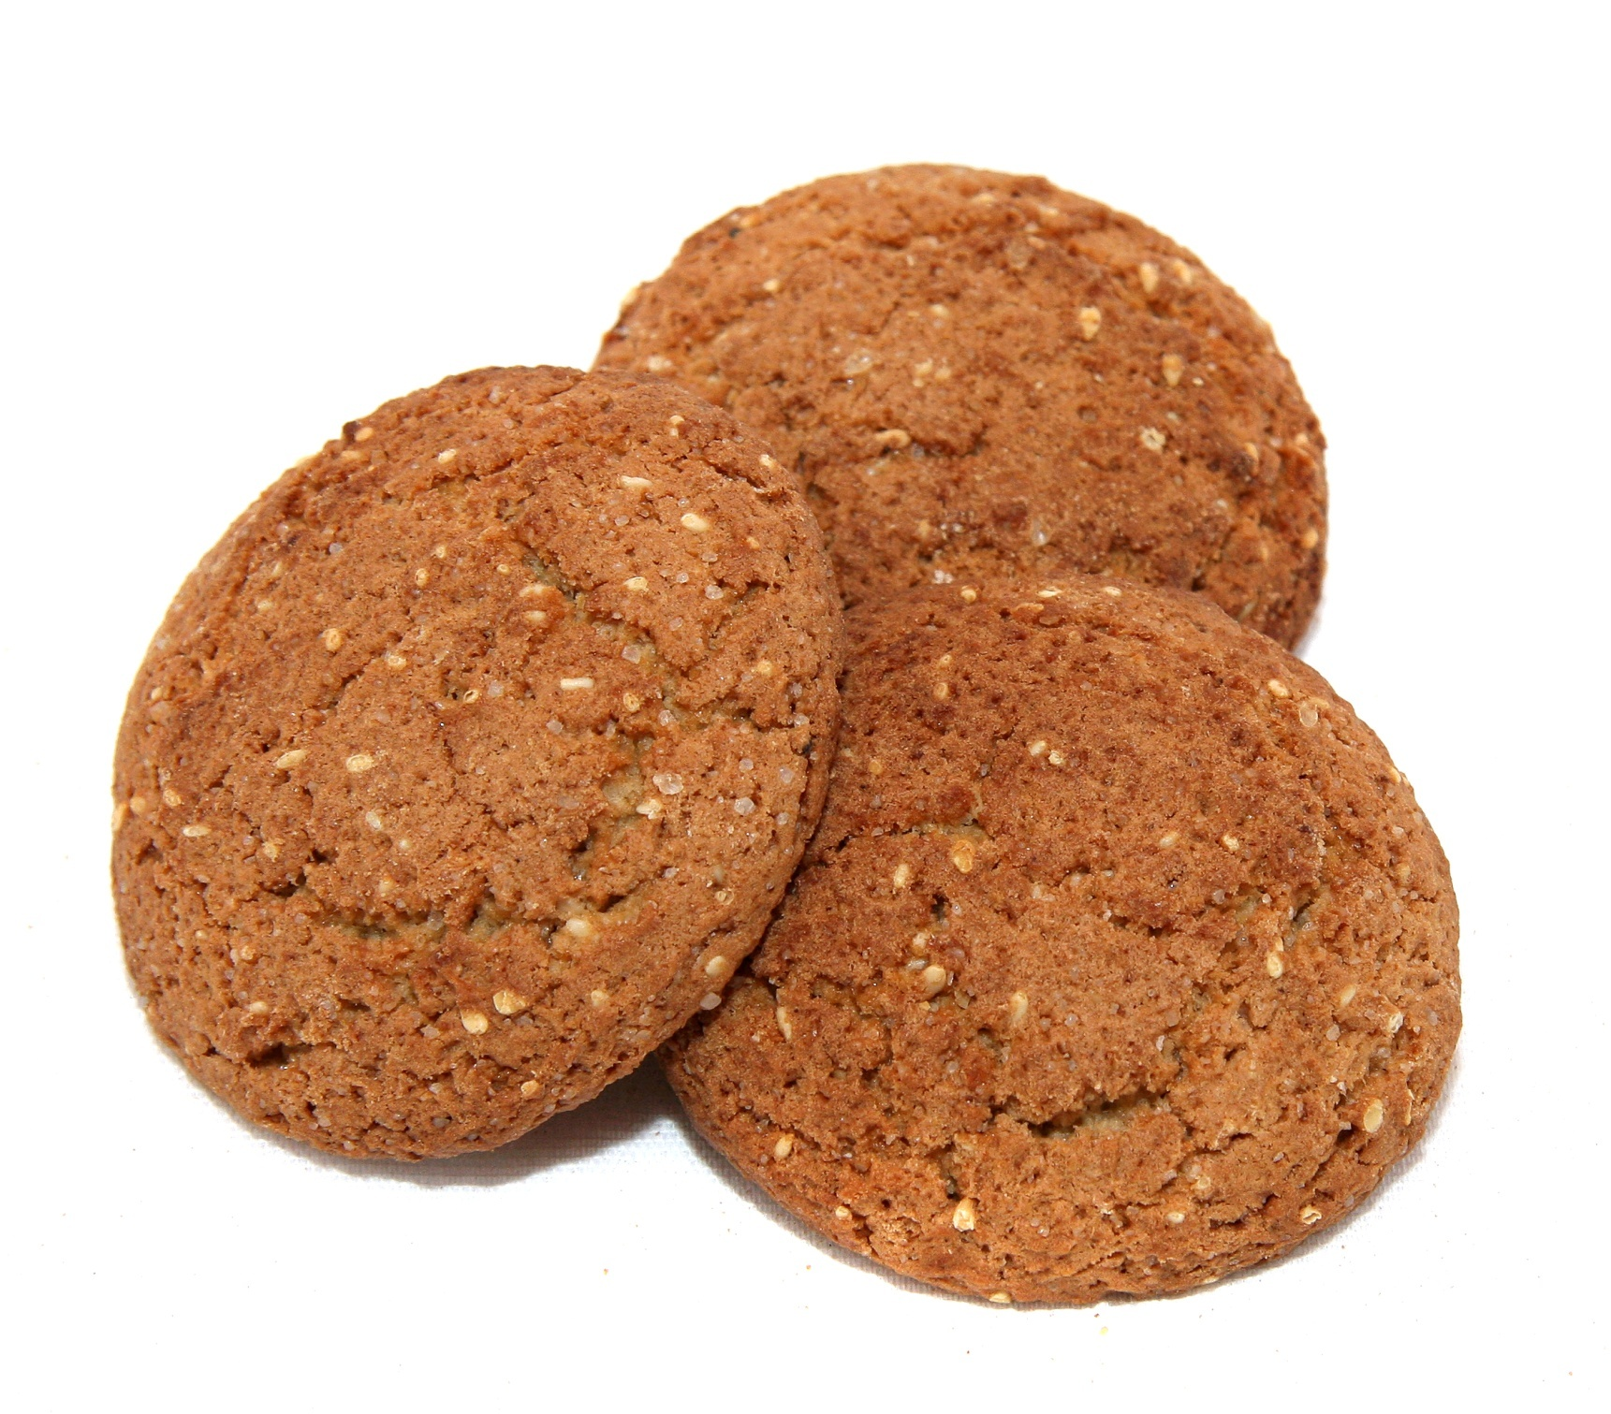  Oatmeal cookie  “Ovsyanoe with prunes” | 5,0 | 1 year | 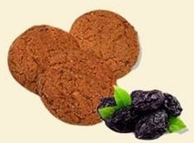 | A cookie is made of mixture of wheat flour and oat flour with sugar, margarine, prunes, iodized salt, sodium bicarbonate, ammonium bicarbonate, flavoring Vanillin.
 | 0,4
Oatmeal cookie  new | 5,0 | 1 year | 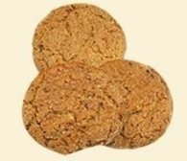 | A cookie is made of mixture of wheat flour and oat flour with sugar, margarine, flavoring Vanillin, dry grape (raisin), iodized salt, sodium bicarbonate.
 | 0,4
Oatmeal cookie  “Ovsyanoe” | 5,0 | 1 year |  | A cookie is made of mixture of wheat flour and oat flour with sugar, butter, flavoring Vanillin, dry grape (raisin), cinnamon, iodized salt, sodium bicarbonate.
 | 0,4

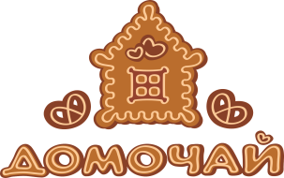

JSC “Bakery-confectionery company “Domochay”
(Confectionery products)

Name | Net weight in a box/package, kg | Shelf life,  days | Picture | Description
Taralli vanilla | 2,0 | 1 year | 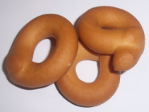 | A product is made of wheat flour with sugar, margarine, baking yeast, iodized salt, flavoring Vanillin.
 | 0,2
Grissini vanilla | 3,0(3,5) | 1 year | 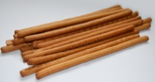 | A product is made of wheat flour with sugar, margarine, baking yeast, iodized salt, flavoring Vanillin.
 | 0,2
Crostini vanilla | 2,5 | 1 year | 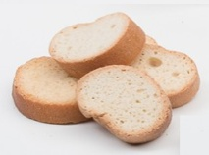 | A product is made of wheat flour with sugar, margarine, baking yeast, dry wheat gluten, iodized salt, flavoring Vanillin.
 | 0,2
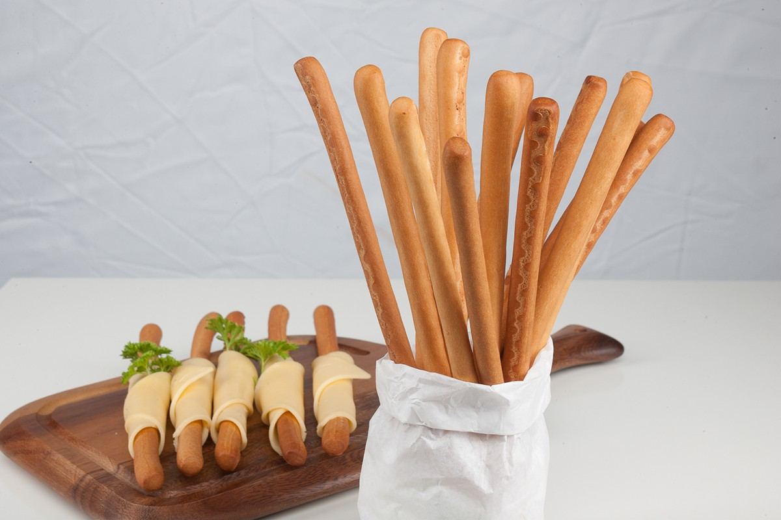  Taralli lenten with poppy seeds | 2,0 | 1 year | 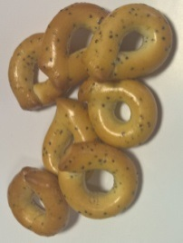 | A product is made of wheat flour with sunflower seed oil, baking yeast, poppy seeds and iodized salt.
 | 0,2
Taralli “Domochay” ordinary | 2,5 | 1 year | 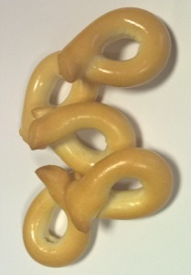 | A product is made of wheat flour with baking yeast and iodized salt.
 | 0,2
Grissini “Bulionnye” with sesame seeds | 2,5(3) | 1 year | 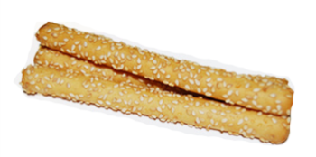 | A product is made of wheat flour with sunflower seed oil, baking yeast, iodized salt, sugar. The surface is sprinkled with sesame seeds.

Name | Net weight in a box/package, kg | Shelf life,  days | Picture | Description
Rye cracker with sesame seeds | 4,0 | 1 year | 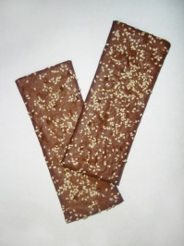 | A product is made of a mixture of rye flour and wheat flour, sunflower seed oil, dry wheat gluten, baking yeast, sugar, kvass wort concentrate, dry bakery mixture “Solodovaya-1”, iodized salt, invert syrup, cumin. The surface is sprinkled with sesame.
 | 0,075
Rye cracker with brans | 3,5 | 1 year | 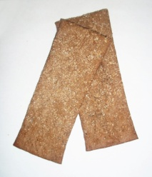 | A product is made of a mixture of rye flour and wheat flour, sunflower seed oil, dry wheat gluten, baking yeast, sugar, kvass wort concentrate, dry bakery mixture “Solodovaya-1”, iodized salt, invert syrup, cumin.
 | 0,075
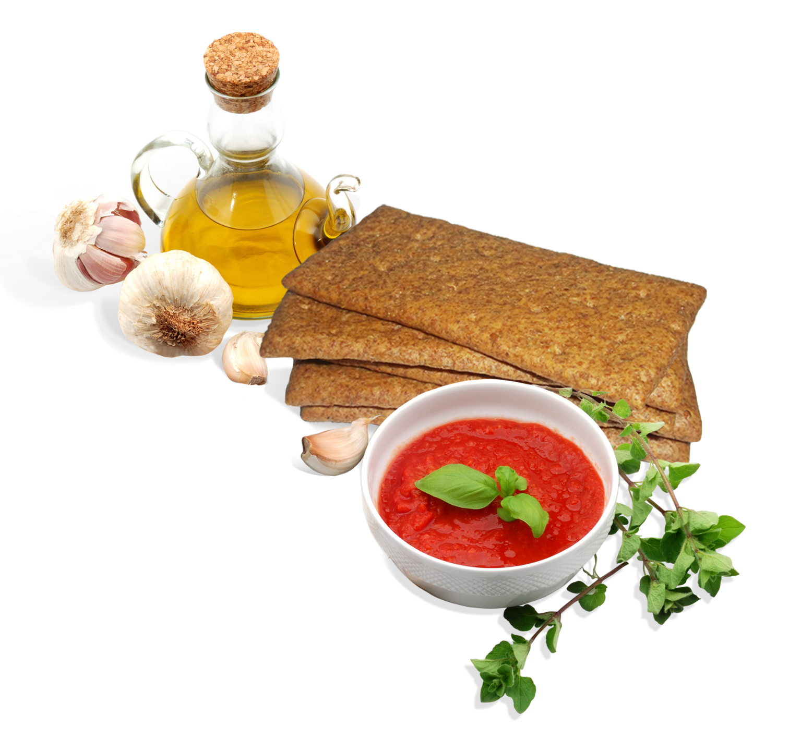  Lenten cracker with rye brans | 4,0 | 1 year |  | A product is made of wheat flour with rye bran, dry wheat gluten, sunflower seed oil, baking yeast, iodized salt, stevia extract. The surface is sprinkled with rye bran.
 | 0,075
Lenten cracker with wheat brans | 4,0 | 1 year | 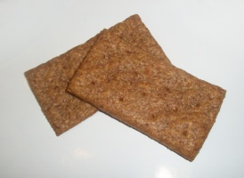 | A product is made of wheat flour with wheat bran, sunflower seed oil, baking yeast, iodized salt, stevia extract.
 | 0,075
Cracker «Domasniy” with sunflower seeds | 4,0 | 1 year | 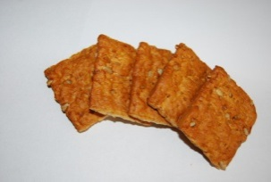 | A product is made of wheat flour, dry wheat gluten, sugar, margarine, sunflower seeds, baking yeast, salt, flavoring Vanillin.
 | 0,075
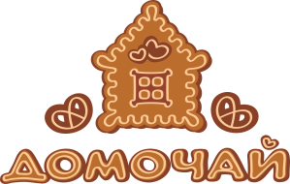

JSC “Bakery-confectionery company “Domochay”
(Confectionery products)

JSC “Bakery-confectionery company “Domochay”
(Frozen confectionery products)
Name | Net weight, kg | Shelf life,  days | Picture | Description
Cake “Domochay”  hazelnut | 1,0 | 1 year | 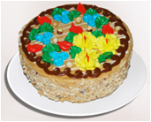 | Layers of air-nut half-finished product, connected with milk and butter cream with cognac. Side surfaces are decorated with cream and crumb of air-nut half-finished product. Top surface is decorated with cream (boiled whole milk condensed milk with sugar, butter “Kr est'janskoe”, chocolate icing), with milk and butter cream, chocolate icing and hazelnut.
Cake “Domochay  Ptich’e moloko” | 0,8 | 1 year | 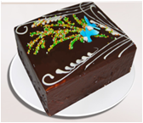 | Layers of sponge cake poured with syrup and connected with soufflé. Top and side surfaces are decorated with chocolate icing.
A layer cake  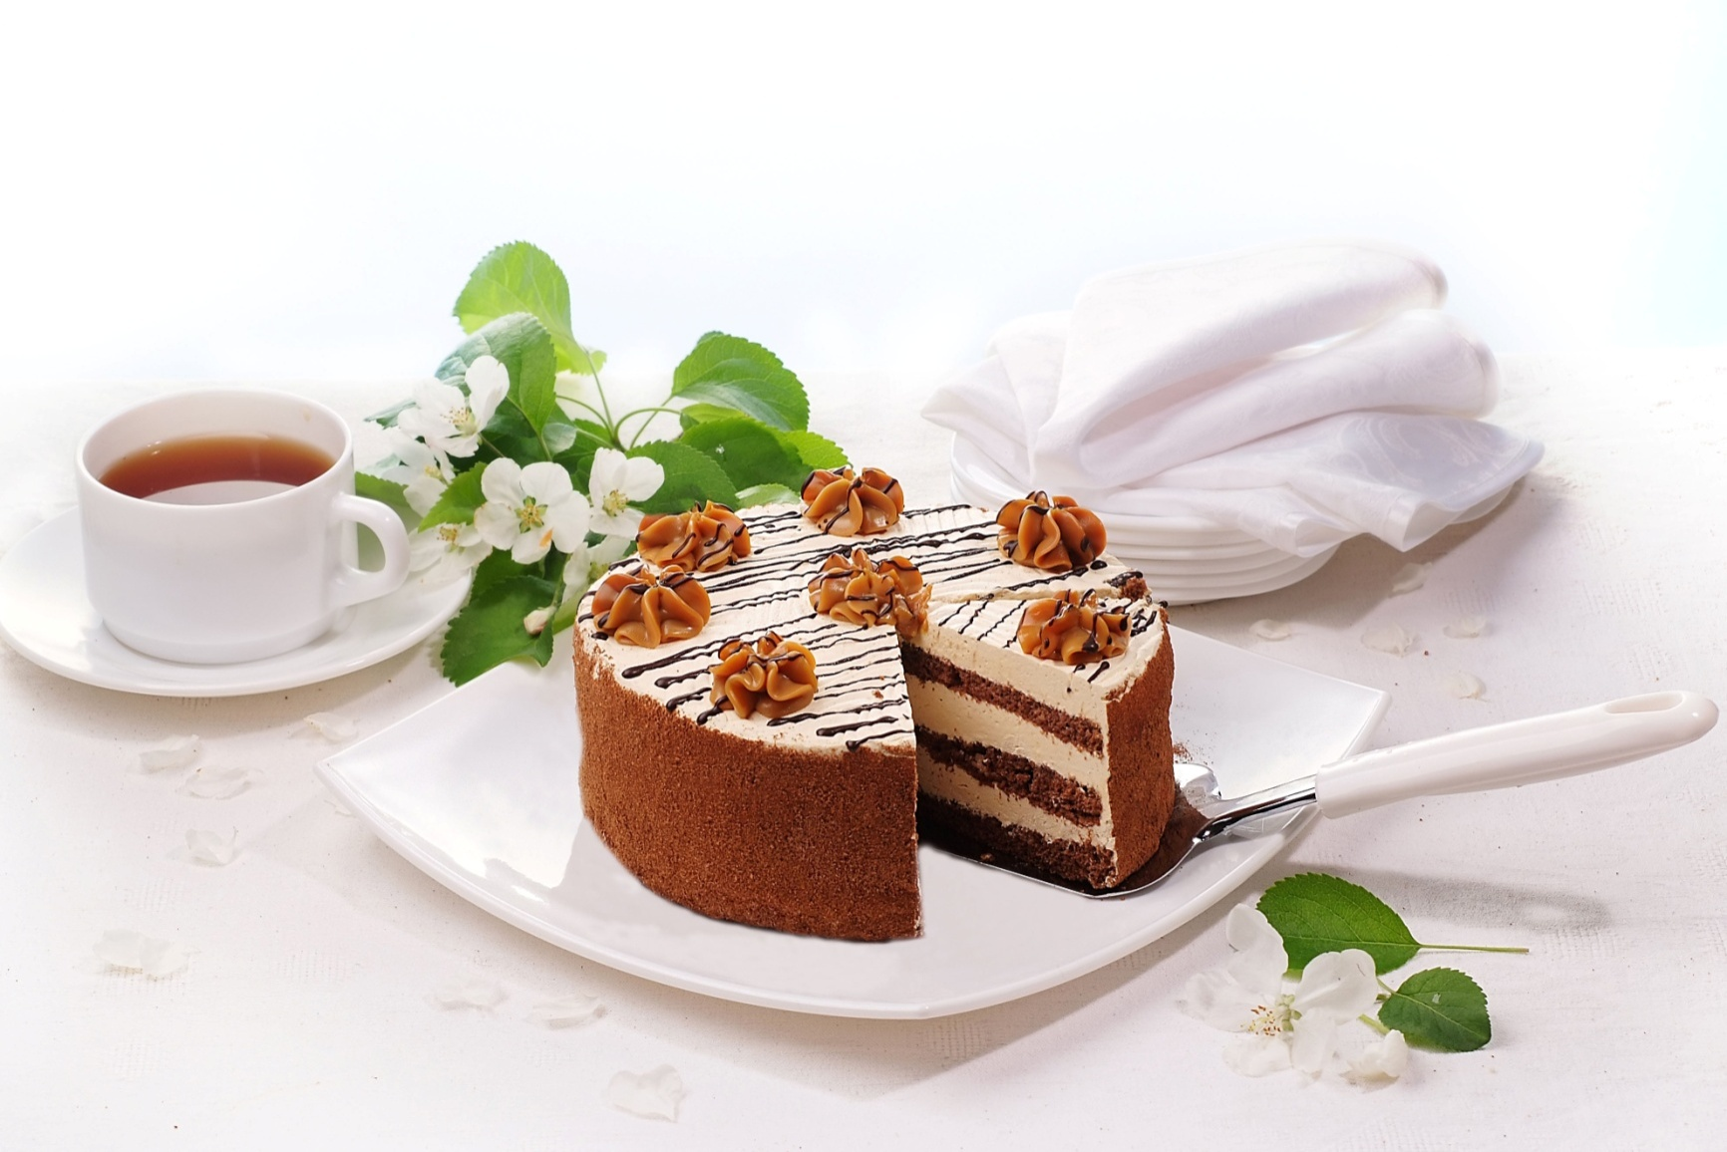  “Domasnhiy” new | 1,0 | 1 year | 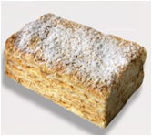 | Layers of puff half-finished product connected with cream (sugar, condensed milk with sugar, margarine, apple jam with flavoring Cherry, flavoring Vanillin, desert wine, cognac, cocoa containing confectionery icing). Top and side surfaces are decorated with a cream and crumbs of puff half-finished product. Top surface is decorated with sugar icing.
Cake “Domochay”  Peanut | 1,0 | 1 year | 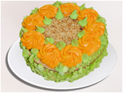 | Layers of air-peanut half-finished product, connected milk and butter cream with cognac. Side surfaces are decorated with cream and crumb of air-peanut half-finished product. Top surface is decorated with cream (boiled whole milk condensed milk with sugar, butter “Krest'janskoe”, chocolate icing), with milk and butter cream, chocolate icing and peanut.
Cake “Oreshek” | 1,0 | 1 year | 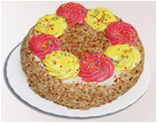 | Layers of sponge cake, connected with albuminous cream (sugar, white egg, icing sugar) with jam. The surface is glazing with albuminous cream, decorated with dried ground peanut and cream.
Cake “Krasnaya gvozdika” | 1,0 | 1 year | 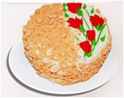 | Layers of air-nut half-finished product, connected with fruit cream. The surface of a cake is covered with cream and decorated with a creamy carnation flower and candied fruit. The side surface is decorated with fruit cream and crumb of air-nut half-finished product.
Cake  “Chio-san” | 1,0 | 1 year | 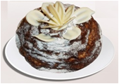 | Layers of half-finished product “Smetannyj” (wheat flour, sour cream, condensed milk with sugar, mélange, sodium bicarbonate), connected with cream (sour cream, boiled condensed milk with sugar “Lakomka”, butter “Krest'janskoe”, sugar, condensed milk with sugar) lay out in a shape of hill. Top and side surfaces are decorated with chocolate icing. Top is also decorated with milk icing.
Cake “Domochay Kievskiy” | 1,0 | 1 year |  | Layers of air-nut half-finished product, connected with cream (sugar, condensed milk with sugar, butter, vanilla powder, desert wine, cognac). Top and side surfaces are decorated with cream. A side surface is decorated crushed nut half-finished product.
- Shelf life of frozen product at storage temperature –(18±2)°C – 3 months
- The transportation of frozen products is made according to the rules of transporting of goods in the vehicles providing temperature conditions not higher -10°C.
- Shelf life of frozen products after defrosting is according to the requirements of TNPA.

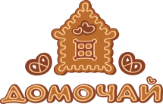
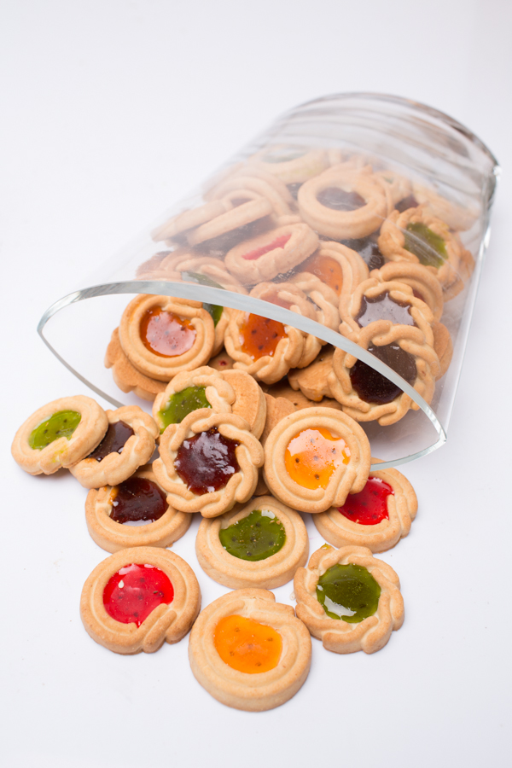

JSC “Bakery-confectionery company “Domochay”
(Frozen confectionery products)

Name | Net weight in a box/package, kg | Shelf life,  days | Picture | Description
Flour sweet  “Bavarskaya”  with sesame seeds | 4,0 | 1 year | 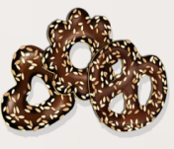 | The product is made of wheat flour with margarine, sugar icing, invert syrup, egg powder, flavoring Vanillin, ammonium carbonate, iodized salt, sodium bicarbonate, complex food additive "Stabilan-Flau NZ", betaviton. The surface is glazed with cocoa containing icing and is covered with sesame seeds.
 | 0,17
Flour sweet  “Domashnyaya”  glazed | 4,0 | 1 year | 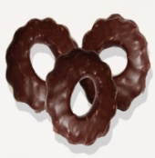 | The product is made of wheat flour with soft confectionery fat "Belomol", sugar icing, invert syrup, egg powder, iodized salt, ammonium carbonate, sodium bicarbonate, flavouring "Vanillin", complex food additive "Stabilan-Flau NZ", betaviton 2%. The surface is glazed with confectionery cocoa containing icing.
 | 0,165
Flour sweet  “Zhemchuzhina” | 3,5 | 1 year | 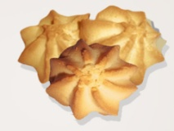 | The product is made of wheat flour with soft confectionery fat "Belmol", melange, invert syrup, sugar icing, ammonium carbonate, iodized salt, sodium bicarbonate, flavoring Creamy, complex food additive "Stabilan-Flau NZ".
 | 0,11
Sugar cookie  “Sbivnoe”  lux | 3,5 | 1 year | 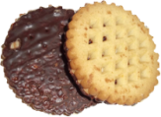 | The product is made of wheat flour with soft confectionery fat "Belmol", sugar icing, invert syrup, egg powder, flavoring Vanillin, betaviton. The bottom of cookie is glazed with confectionery cocoa containing icing.
 | 0,19
Sugar cookie  “Sbivnoe”  Lenten | 3,5 | 1 year | 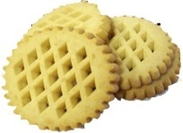 | Sugar cookie is made of wheat flour with sunflower seed oil refined and deodorized, sugar icing, invert syrup, flavoring Cream - Vanilla, ammonium carbonate, iodized salt, sodium bicarbonate.
 | 0,18
Cookie with bran | 3,5 | 1 year | 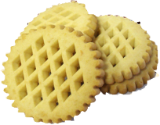 | Sugar cookie is made of wheat flour with margarine, wheat bran, sugar icing, invert syrup, egg powder, iodized salt, ammonium carbonate, flavoring Vanillin, sodium bicarbonate and betaviton.
 | 0,17
Biscuit set “Domochay” №31 | 1,0 | 1 year | 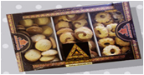 | Sweet flour and biscuit set «Domochay» №31 consists of three kinds of biscuits: sweet flour «Domashnyaya»; sweet flour «Domochay» simple, sweet flour “Labirint”.

Biscuit set “Domochay” №41 | 1,0 | 1 year | 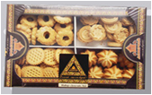 | Sweet flour and biscuit set «Domochay» №41 consists of four kindsof biscuits: sweet flour «Zhemchuzhina»; cookie «Pugovka»; sweet flour «Domashnyaya»; sugar cookie «Sbivnoe».
Biscuit set “Domochay” №61 | 1,0 | 1 year | 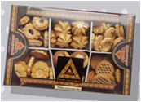 | Sweet flour and biscuit set «Domochay» №61 consists of six kinds of biscuits: sweet flour «Zhemchuzhina»; cookie «Pugovka»; sweet flour «Domashnyaya»; cookie with bran, sugar cookie “Mu-mu”, sweet flour “Labirint” new.
Biscuit set “Domochay” №34 | 1,0 | 1 year | 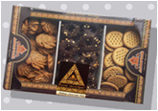 | Sweet flour and biscuit set «Domochay» №34 consists of three kinds of sweet flour: biscuit «Ptichka-sinichka»; sweet flour «Domashnyaya» with peanut; sugar cookie «Sbivnoe» lux.
Biscuit set “Domochay” №44 | 1,0 | 1 year | 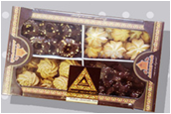 | Sweet flour and biscuit set «Domochay» №44consists of four kinds of biscuits: biscuit «Ptichka-sinichka»; sweet flour «Domashnyaya» with peanut; sweet flour «Zhemchuzhina», sweet flour «Bavarskaya».
Biscuit set “Domochay” №64 | 1,0 | 1 year | 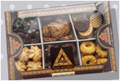 | Sweet flour and biscuit set «Domochay» №64 consists of six kinds of biscuits: biscuit «Ptichka-sinichka»; sweet flour «Domashnyaya» with peanut; sweet flour «Domashnyaya»; sweet flour «Zhemchuzhina»; sweet flour «Bavarskaya»; sugar cookie «Sbivnoe» lux.
Tea beverage “Ivan-Chay Domochaevskiy” | 0,05 | 1 year | 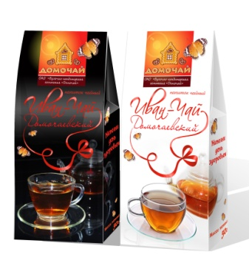 | A tea beverage «Ivan-Chay «Domochaevskiy» can be used as a separate beverage and also as an addition to another tea for improvement of taste and flavor.
- Shelf life of frozen product at storage temperature –(18±2)°C – 3 months
- The transportation of frozen products is made according to the rules of transporting of goods in the vehicles providing temperature conditions not higher -10°C.
- Shelf life of frozen products after defrosting is according to the requirements of TNPA.

№ | Product name | Net weight, kg | Expiration date of a frozen bread | Desciption | Picture
1 | Bread «Mogilevskiy» elite | 0,8 | 1 year | A scalded bread, is made of a mixture of rye and wheat flour with dry rye malt, sugar, kvass wort concentrate, sunflower seeds, wheat gluten, salt, yeast. | 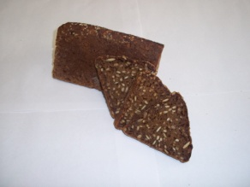
2 | Bread «Imperatorskiy» | 0,6 | 1 year | A scalded bread, is made of a mixture of rye and wheat flour with rye malt, honey, kvass wirt concentrate, dried grapes (raisin), dried plum (prunes), dried apricots, hazelnut, sunflower seeds, pumkin seeds, salt, baking yeast. | 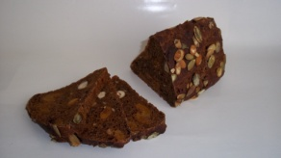
3 | Bread «Borodinskiy» | 0,8 | 1 year | A scalded bread, is made of a mixture of rye and wheat flour with rye malt, honey, kvass wort concentrate, a bakery mixture "Solodovaya-1", salt, baking yeast. The surface is civered with coriander. | 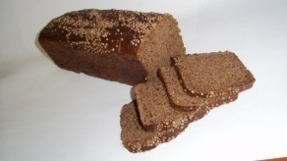
4 | Bread «Borodinskiy» | 0,6 | 1 year | A scalded bread, is made of a mixture of rye and wheat flour with rye malt, honey, kvass wort concentrate, a bakery mixture "Solodovaya-1", salt, baking yeast. The surface is civered with coriander. | 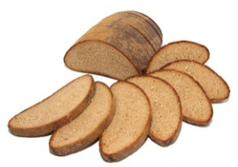
5 | Bread «Lazarevskiy» | 0,9 | 1 year | A scalded bread, made of a mixture of rye and wheat flour with rye malt, kvass wort concentrate, honey, apple jam, salt. | 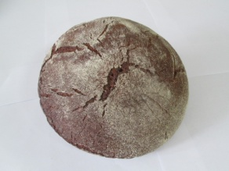
6 | Bread «Mogilevskiy» with sunflower seeds | 1,1 | 1 year | A scalded bread, is made of a mixture of rye and wheat flour with rye malt, sunflower seeds, pumkin seeds, kvass wort concentrate, apple jam, baking yeast, mashed potatos, salt. | 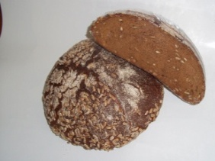
7 | Bread «Narochanka». | 1,2 | 1 year | A scalded bread, made of a mixture of rye and wheat flour with rye malt, kvass wort concentrate, apple jam, bakery yeast, salt, honey, caraway seeds, dry parfume. | 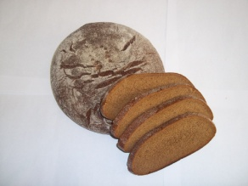
8 | Bread «Mogilevskiy» premium | 0,6 | 1 year | A scalded bread, is made of a mixture of rye and wheat flour with dry rye malt, sugar, kvass wort concentrate, sunflower seeds, wheat gluten, salt, yeast.
9 | Bread  «Domochay» zernovoy | 0,9 | 1 year | A bread is made of wheat flour with wheat seeds, wheat gluten, sugar, margarine, baking yeast, salt. | 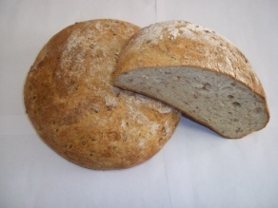
10 | Bread «Beresnevskiy» with caraway seeds | 0,9 | 1 year | A scalded bread, is made of a mixture of rye and wheat flour with rye malt, kvass wort concentrate, salt, baking yeast and cumin. | 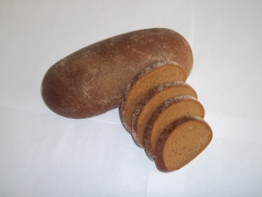
11 | Bread «Domochay» litovskiy dark | 0,4 | 1 year | The scalded bread is made of rye flour, dry rye malt, sunflower seeds, sugar, a dry bakery mixture “Solodovaya-1”, kvass wort concentrate, malt extract “Jachmennyj svetlyj”, caraway seeds, sesame seeds, salt, a mixture “Tostovaya”, bakery yeast. | 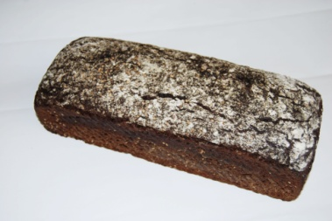
12 | Bread «Domochay» litovskiy light | 0,4 | 1 year | The scalded bread is made of the mixture of rye flour and wheat flour, dry rye malt, sugar, dry wheat gluten, sunflower seeds, sesame seeds, caraway seeds, salt, a mixture “Tostovaya”, bakery yeast. | 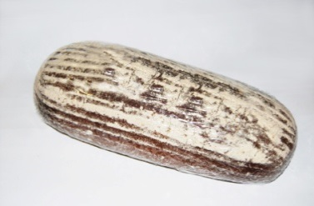
13 | Bread «Domochay» rye with caraway seeds | 0,4 | 1 year | The scalded bread is made of the mixture of rye flour and wheat flour, dry rye malt, sunflower seeds, sugar, kvass wort concentrate, bakery yeast, salt, cumin, dark malt extract. | 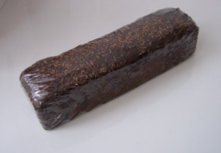
14 | Bread «Debryanskiy» non-yeasted | 0,9 | 1 year | A scalded bread, made of a mixture of rye and wheat flour with rye malt, kvass wort concentrate, honey, apple jam, salt.
15 | Long loaf «Gabrovskiy» | 0,5 | 1 year | A product is made of wheat flour with sugar, margarine, baking yeast and salt. | 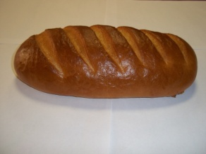
16 | Pie «Postniy» with poppy seeds | 0,4 | 1 year | A product is made of wheat flour, sunflower seed oil, baking yeast, salt, improver “Plissa-15” with poppy seeds and sugar filling. | 