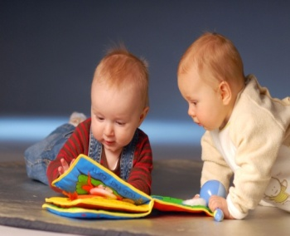
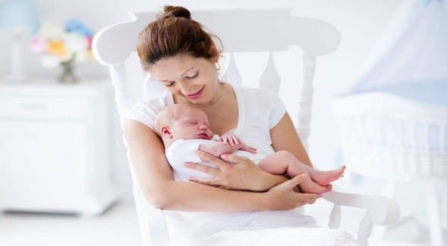

Project initiative
«Mother's school»
1. Project Name: «Mother school»
2. Project implementation Period: 2 years
3. The applicant Organization offering the project initiative: state educational institution «kindergarten No. 6 Mosty», Grodno region, Republic of Belarus
4. The goal of the project initiative: to create conditions for the physical and psychological well-being of women in the city of Mosty, Mostovsky district, Grodno region in the prenatal and post-prenatal periods, harmonious development of the personality of children from 0 to 6 years old for medical, psychological and pedagogical support.
5. Tasks planned for implementation within the framework of the project initiative:
1) create a safe and comfortable educational space for prenatal and post-Natal sessions with women;
2) equip on the basis of nursery-garden No. 6 in Mosty is a safe play area for psychological comfort of pregnant women and mothers with young children, implementation of various educational and game activities, taking into account the interests and capabilities of young children;
3) organize medical, psychological, and pedagogical interaction on the basis of nursery school No. 6 in Mosty, Grodno region, with women in the prenatal and post-prenatal periods;
4) organize comprehensive support for young parents (dads and moms) in the process of preparing for the birth of a baby and help them gain experience in raising a child
from 0 to 3 years old;
5) raise the level of psychological and pedagogical culture of young parents;
6) contribute to the successful adaptation of a 2-3-year-old child to the conditions of a pre-school education institution;
7) promote minimization of risks associated with the birth of children with special needs;
8) accompanying families raising a «special» child.
6. Target group: pregnant women, dads, young mothers (from 16 to 45 years old)
of Mosty, Mostovsky district, children aged from 0 to 3 years, teachers of nursery school No. 6.Bridges (teacher-psychologist, preschool teachers, social teacher, head of physical education), doctors (gynaecologist, pediatrician).
7. Brief description of the project initiative activities:
- arrangement of a safe room for classes on relieving emotional tension, anxiety in pregnant women, new mothers, dads, and training in self-regulation techniques;
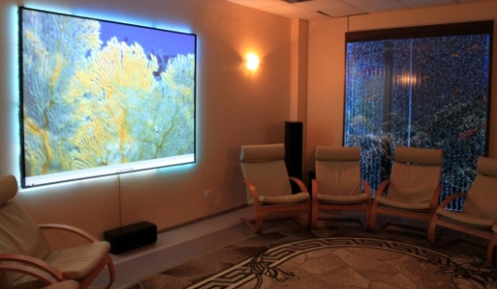

- pacquisition and installation of computer and music equipment (production of printed information for participants of the project initiative, for broadcasting presentations by specialists, for voicing musical works during relaxing classes / auto-trainings with pregnant women, young mothers and fathers with children from 0 to 3 years old);
- purchase and installation of sensory gaming equipment for the development
of emotional and physical skills, qualities of children from 0 to 3 years, for training sessions of young parents (moms and dads);
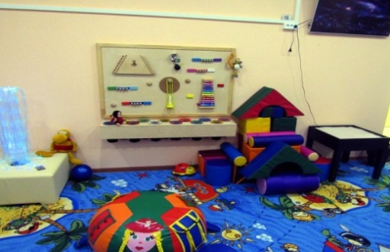

- providing project initiative to specialists of nursery school No. 6 in Mosty (teacher-psychologist, head of physical education, music Director, preschool teacher), health care institution «Mostovskaya Central district hospital»: gynecologist, pediatrician, psychologist for conducting classes with participants of the project initiative;
- presentations of the results of the project initiative implementation
- professional development of specialists in the field of «maternity Programs» in the Republic of Belarus.
8. Total funding (in US dollars): 30 000

Source of funding | Amount of funding(in US dollars))
Donar's funds | up to 30 000
Co-financing | -
9. Place of implementation of the project initiative: region/district, city):
Grodno region, Mostovsky district, Mosty, Stantsionnaya str., 73

10. Contact person: project initiative manager: Nenadovich Galina Alexandrovna, +375(01515)64423, sad6mosty@tut.by
initials, surname, position, phone number, email address:
KASKO Larisa Vladimirovna, head of the state educational INSTITUTION «Nursery school No. 6 c/ Mosty»,
+375 (01515)60372, sad6mosty@tut.by

