ЗАЯВКА НА ФИНАНСИРОВАНИЕ ГУМАНИТАРНОГО ПРОЕКТА
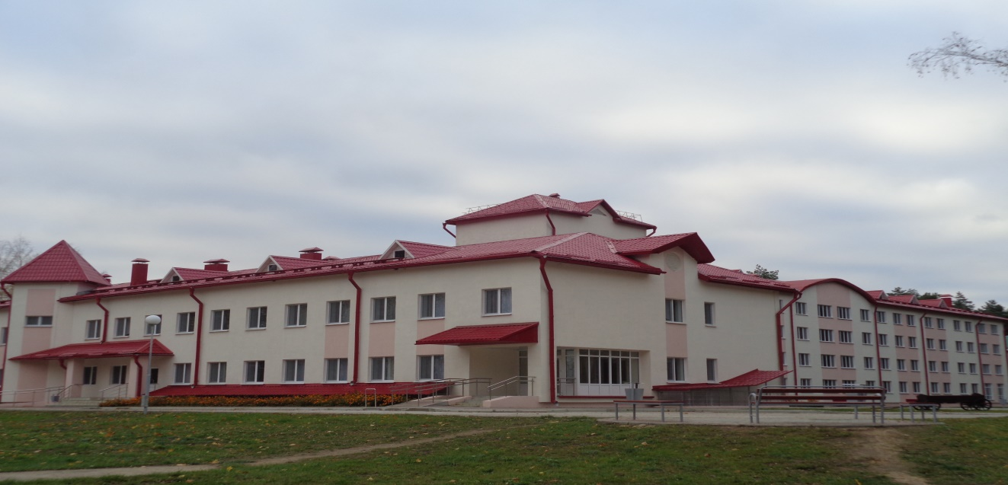
1. | Name of the project | "Caring for your neighbor"
2. | Name of the organization | State Institution of Social Services "Chausky Psycho-Neurological Boarding Home for the Elderly and Disabled"
3. | Physical and legal address of the organization, phone, fax, e-mail | 213206, Mogilev region, Chaussky district, Rosinka village, st. Social, 3, tel. +3752242 7-11-92, fax +3752242 7-11-97, e-mail: Chausu.di@mintrud.by
4. | Information about the organization | The boarding house was created in 1992 with the aim of providing citizens of the Republic of Belarus, foreign citizens and stateless persons who permanently reside in the Republic of Belarus, who have reached the age of age, giving the right to an old-age pension on a common basis, disabled people of groups I and II, recognized in the established manner incapacitated, having lost full or partial ability to self-care, in need of care, assistance, domestic and medical services, special residential premises for permanent and temporary residence.
5. | Head of the organization | Voevodova Tatyana Leonidovna, Director, tel. +3752242 7-11-92
6. | Project Manager | Zhuravkova Irina Vladimirovna, legal adviser, tel. +3752 242 7-09-40
7. | Previous assistance received from other foreign sources | International Public Association "Help People" in the form of vegetable seeds
8. | Required amount | 50 000 $
9. | Co-financing | Extrabudgetary funds
10. | Project term | From 01 July 2022 to 30 September 2022
11. | Project objective | Maximum integration of people with disabilities into society, including wheelchair users
12. | Project objectives | • Ensure the participation of people with disabilities in cultural events, provide them with the opportunity to get acquainted with the cultural, historical and spiritual sights of Belarus;  • Expand the accessibility of environment and services for the participation of people with disabilities on an equal basis with other citizens in socio-cultural life;  • Expand the circle of contacts of people with disabilities;  • Adapt disabled people in modern society.
13. | Detailed description of the activities within the project in accordance with the tasks set | Purchase of a minibus for full-fledged socio-cultural rehabilitation of people with disabilities (18 seats: 14 - for people with disabilities, including people with wheelchair disabilities, 4 - for accompanying persons).
14. | Justification of the project | The purchase of a special vehicle with a lifting device will allow people with disabilities, including people with disabilities in a wheelchair, to participate in regional, regional and republican sports events and competitions for people with disabilities, to get acquainted with the cultural, historical and spiritual sights of Belarus, which will increase the level of personal growth and self-esteem of people with disabilities.
15. | Post-project activities | The implementation of the project will increase the level of personal growth and self-esteem of people with disabilities living in a boarding house.
16. | Project budget | 50 500 $

