HUMANITARIAN PROJECT FINANCING APPLICATION
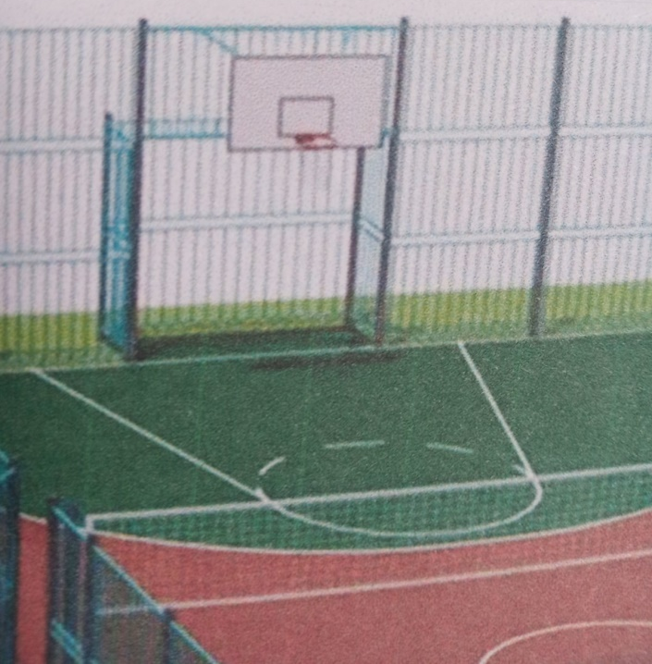

1. | Project name | Sports and playground for disabled children “This life is for you”.
2. | Organization name | Educational institution “Osipovichi state special general education boarding school for children with disorders of the musculoskeletal system”
3. | Physical and legal address of the organization, phone, fax, e-mail | Republic of Belarus, Mogilev region, Osipovichi, Stashkevich str., 33-A,  tel. 8-02235-57647, fax 8-02235- 57617,  e - mail address – os-school2013@yandex.by
4. | Information about the organization | The educational institution "Osipovichi state special general education boarding school for children with disorders of the musculoskeletal system" was founded in September 1964. The main purpose of the institution is the implementation of the state educational standards of special education, the formation of an educated, socially, spiritually and morally mature, creative personality, instilling healthy lifestyle skills, as well as a social goal, as a result of adaptation, rehabilitation and correction of the development of children with special psychophysical development, preparation for an independent lifestyle.
5. | Head of organisation | Gormash Larisa Adamovna, principal of Osipovichi special boarding school,  tel. 8-02235-57647
6. | Project manager | Barkovskaya Liliya Kazimirovna, vice principal for educational work
7. | Previous financing received from other foreign sources | Was not provided
8. | Required amount | 41 000 $
9. | Co-financing | 2 000 $
10. | Project duration | Two years
11. | Project aim | Creation of optimal conditions for physical development and health improving of children with disorders of the musculoskeletal system, for interaction and equal communication between healthy children and disabled children, the possibility of their early social adaptation.
12. | Project objectives | - to create children sports and playground, providing the opportunity for children with disorders of the musculoskeletal system to do sports safely on the universal fenced sports ground with rubber cover;  - to make a list of the necessary sports equipment for the universal sports and playground;  - to increase the number of children doing different kind of sports;  - to promote a healthy lifestyle.
13. | Detailed description of the project activities in accordance with the objectives | - the design of sports and playground project;  - cover device size 25x40;  - fence size 25x40;  - purchasing of sport equipment for the sports and playground;  - purchasing of equipment for the training area.  Target group: students of Osipovichi special boarding school of different ages  (62 students).  Increasing the number of children involved in physical culture through the holding of mass sport events, sport holidays, the work of sports clubs for general health improvement and useful leisure time of students.
14. | Project background | Sports and playground is designed for correction of the musculoskeletal system, development of sport skills and the increasing of motor activity of children with disorders of the musculoskeletal system and disabled children. Exercising on the sports playground helps to increase motivation for regular classes in adaptive physical culture and sport of children with disorders of the musculoskeletal system, disabled children, improving their physical health.
15. | Post-project activities | 1. Conducting lessons with the children with disorders of the musculoskeletal system and disabled children in adaptive physical culture, therapeutic physical training on the universal sports ground.  2. Widening of sports events to increase the coverage of student busyness and diversity of physical work.  3. Holding different cooperative sports competitions, events for children with disorders of the musculoskeletal system and healthy children to increase the level of socialization, integration of children with disorders of the musculoskeletal system into society, the development of inclusive processes.  4. Improving the health of children with disorders of the musculoskeletal system and disabled children by increasing the availability and quality of physical education and sport, preventing diseases.
16. | Project budget | 43 000 $

