APPLICATION FOR FINANCING OF A HUMANITARIAN PROJECT
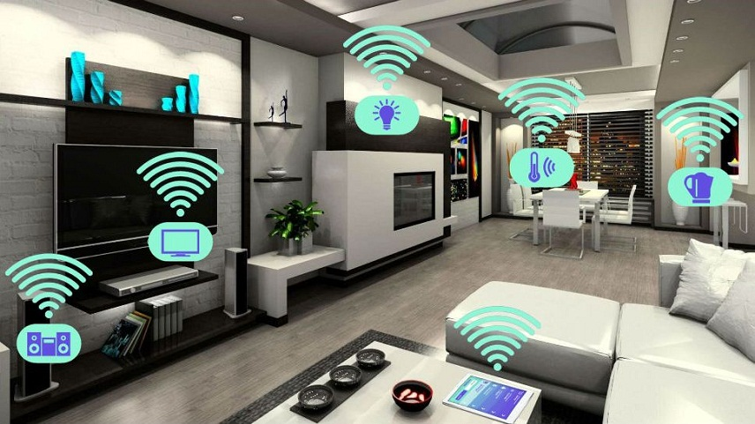
1 | Name of the project | The project "Smart home for an independent life"
2 | Name of the organization | State Social Service Institution "Vesnovsky Boarding House for disabled children with special needs of psychophysical development"
3 | Physical and legal address of the organization, phone, fax, e-mail | Glussky district, Vesnovo village, 8-02230-74084, vesnov04di@gmail.com
4 | Information about the organization | There are 159 pupils living in the boarding house. Children and young people with disabilities need constant medical care and social care. The institution has created the necessary conditions for safe and comfortable living of pupils; educational, educational, rehabilitation work is carried out  There are 159 pupils living in the boarding house. Children and young people with disabilities need constant medical care and social care. The institution has created the necessary conditions for safe and comfortable living of pupils; educational, educational, rehabilitation work is carried out
5 | Head of the organization | V.V.Klimovich, director of the boarding house, 8 02230 74084
6 | Project Manager | V.V.Klimovich, director of the boarding house, 8 02230 74084
7 | Previous assistance received from other foreign sources | In 2016, the initiative of the boarding house "Organization of a carpentry shop for the employment of disabled people" became the winner in the 1st Competition of local initiatives within the framework of the international technical assistance project.  Since 2017, two pilot programs initiated by the Irish charity organization "Chernobyl Children's Project International Limited" have been implemented in the boarding house:  "Restoration of legal capacity". The purpose of the program is to restore the legal capacity of boarding school students over the age of 18;  "Acquisition of life skills". The purpose of the program is to teach household skills to pupils who have the potential for independent independent living or living under supervision after reaching the age of 18
8 | Required amount | 250 000 $
9 | Co-financing | -
10 | Project term | 5 years
11 | Project objective | Expansion of social interaction of pupils and graduates of the GUSO "Vesnovsky boarding school for disabled children with special needs of psychophysical development" through the introduction of an alternative form of residential boarding schools for people in need of outside help and care
12 | Project objectives | 1. To create a comfortable environment for communication and work activities of graduates of the Vesnovsky boarding school and participants of the projects "Program for the restoration of legal capacity", "Program for the acquisition of life skills" GUSO "Vesnovsky boarding school for disabled children with special psychophysical development";  2. Create a living environment by organizing a competent, maximally convenient functional zoning of the house, technical equipment, furniture adapted to the needs of wheelchair users;  3. To provide graduates of the GUSO "Vesnovsky boarding school for disabled children with special needs of psychophysical development" with the necessary and sufficient support;  4. To provide graduates of the GUSO "Vesnovsky boarding school for disabled children with special needs of psychophysical development" with housing in a "smart home for independent living"
13 | Detailed description of the activities within the project in accordance with the tasks set | 1. Development of the project of a single-storey building, utility rooms (garage, warehouse, vegetable storage, livestock facilities, laundry bath, gazebo), house territory (parking lot, parking lot for stopping and unloading vehicles, laundry drying area, paths).  2. Construction of a single-storey building, utility rooms, house territory the urban settlement of Glusk.  3. Purchase of furniture and necessary equipment for the house, utility rooms, house territory.  4. Arrangement of the house, outbuildings, house territory.  5. The placement of graduates: creating the necessary conditions for accommodation of a particular person with disabilities, employment (social workers to care for the wheelchair in the "smart house for independent living", in other institutions of Glusk, if there are jobs), leisure activities, etc.  6. The organization of social services in the necessary and sufficient graduates of the orphanage
14 | Justification of the project | "Nothing for us - without us" is a famous principle that is now increasingly heard in society.  The idea of creating a project "Smart home for an independent life" belongs to a young wheelchair user, participant of the project "Restoration of legal capacity" Alexander Goldaev.  Alexander understands that to create a truly "smart home" is difficult and very expensive, but he wanted was a technical device that will allow him to partially control their own lives, to interact with the world surrounding things: turn on and turn off the TV, light; to open and close the blinds; of self-drive in the right room, etc.  "Smart house for independent living" in the view of Alexander Goldaeva:  There are no thresholds in the house, the doorways are wide, the minimum number of doors. A wheelchair can easily travel from one room to another. Switches and sockets are located where they are accessible to a person in a wheelchair. The bed is wide and the same height as the stroller. There is a table near the bed, its surface can change position, the table has wheels and moves easily. There is a wheelchair access to tables, sinks, cabinets, etc. The bathroom is equipped with a spacious shower cabin with a pallet at the floor level, a toilet with a seat located at the height of a wheelchair and having convenient handrails for transplanting, as well as a washbasin with a large space under it for a barrier-free entrance. Glazed veranda that opens onto the courtyard. The house should have guest rooms in which participants of the projects "Disability Recovery Program", "Life Skills Acquisition Program", guests can live.  The house is equipped with technical means that help to cope with "everyday trifles": turn on the light, open the curtains, close the doors, etc.  It is convenient to move around the yard and utility rooms in a wheelchair.  There is a small vegetable garden, greenhouse, pets and birds: chickens, rabbits, pigs.  Graduates of the Vesnovsky boarding school live in the house. They can work here as well. For example, social workers, helping wheelchair users, and can be employed in any institutions of the district.  The participants of the projects "Disability Recovery Program", "Life Skills Acquisition Program" temporarily live in the house for the practical consolidation of the skills they received in the classroom, since it is more convenient to visit shops, a cinema, a hospital and other significant facilities while living in the town of Gluska.  The participants of the projects "The Program for the restoration of legal capacity", "The Program for the acquisition of life skills" live in a "smart home for independent living" under the supervision of employees of the Vesnovsky boarding house, and graduates are accompanied by social workers of the Institution "Glussky district Center for Social Services of the population"
15 | Post-project activities | The new living conditions of the participants of the projects "Disability Recovery Program", "Life Skills Acquisition Program" in the "Smart home for independent living" will contribute to improving and changing (restoration of legal capacity, non-registration of legal capacity) the social status of people with disabilities. And they will also allow you to accompany graduates of a boarding school to the extent necessary, and not according to the standards of service established based on the disability group.  Living in a "smart home for an independent life" will be based on mutual assistance. Project participants and graduates of the boarding school will help each other in carrying out daily activities, obtaining the necessary information, solving household and other issues
16 | Project budget | 250 000 $

