Humаnitаrian рrоjекt
«SPORT FOR ALL!»

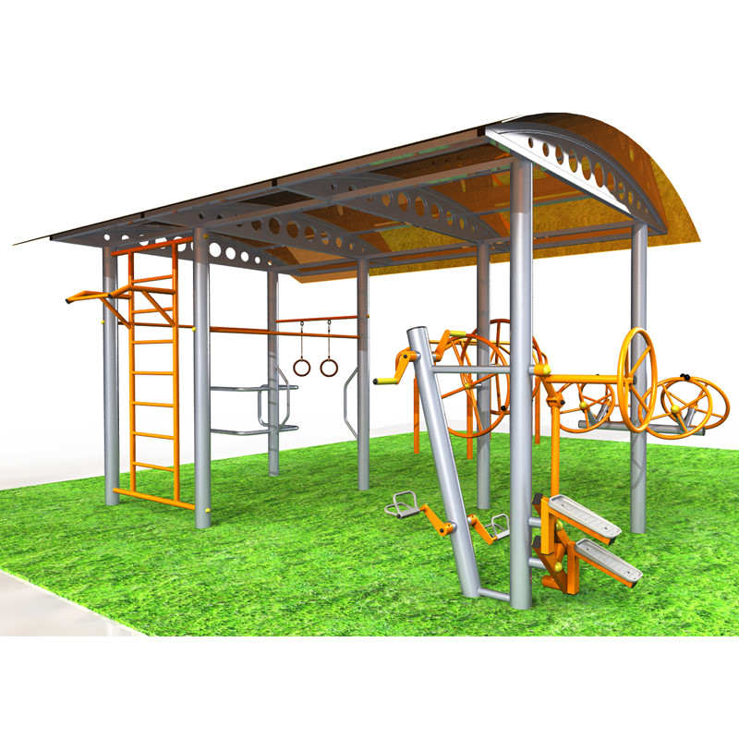

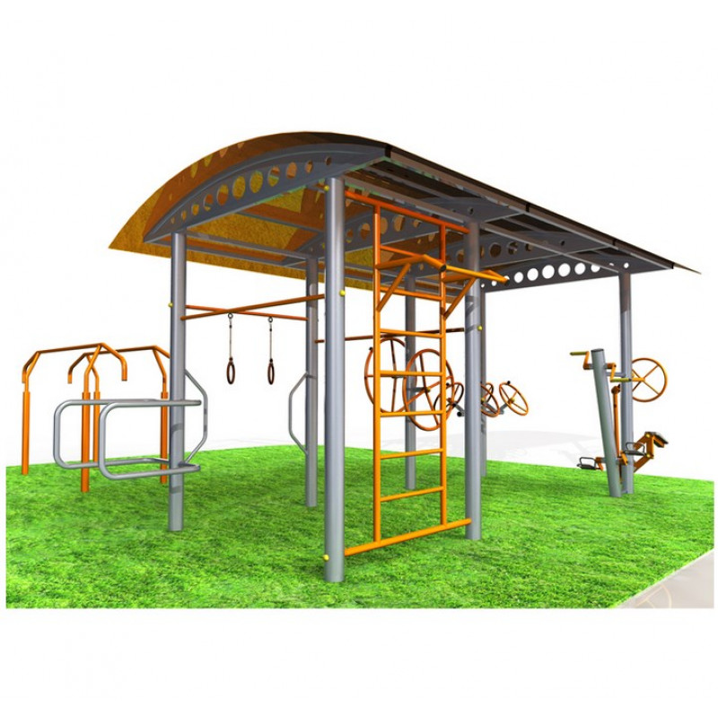

1. | Name of the project | «Sport for all!»
2. | Name of the organization | Sports and Tourism Sector of the Dokshitsy Regional Executive Committee
3. | Аddress of the organization, telephone, fax, e-mail | Vitebsk Region, Dokshytsy,  Shkolnaya street, 19, 2111722  Tel./fax 8(02157)59971  fck_dok@mail.ru
4. | Head of the organization, project manager | Adzintsova Tatsiana, head of the sector, +375333060616
5. | Required amount | 20 000 belarusian rubles
6. | Co-financing | Regional budget
7. | Project term | 6 months from the start of the project
8. | Goal of the project | Involving people with disabilities in physical education and a healthy lifestyle
9. | Objective of the project | - Equipping the sports ground with special mechanical simulators for sports for people with disabilities.  - Attraction of people with disabilities to physical culture in order to maintain health and maintain an active lifestyle.  - Assistance in the prevention of diseases of the musculoskeletal system, cardiovascular and respiratory diseases; implementation of the general improvement of people with disabilities.  - Organize an open group lesson using a special mechanical simulator for people with disabilities.
10. | Mission of the project | Many sports grounds are designed for citizens without physical disabilities Unfortunately, almost all playgrounds cannot offer people with disabilities to do sports in free access in the conditions necessary for them and with specialized equipment. When developing the idea of a sports ground, such sports simulators are considered that playground’s visitors could master and ensure the safety of exercises.  This project has a social orientation therefore, funds and charitable assistance are required for the implementation of the project.
11. | Post-project activities | - to open sport area,  - conducting individual and group classes by an instructor-methodologist on physical culture and health-improving and sports-mass work with people with disabilities,  - independent physical education.  - assistance in the prevention of diseases of the musculoskeletal system, cardiovascular and respiratory diseases,  - increasing resistance to stressful situations, reducing emotional stress, improving concentration,  - improving the quality of life of people with disabilities by expanding the range of services provided and the possibilities for their implementation.
13. | Budget of the project | Costs according to design and estimate documentation.

