Humanitarian project«The Path of Good» - improvement of medical and social help provided to the citizens of pension age and disabled people of Miory district
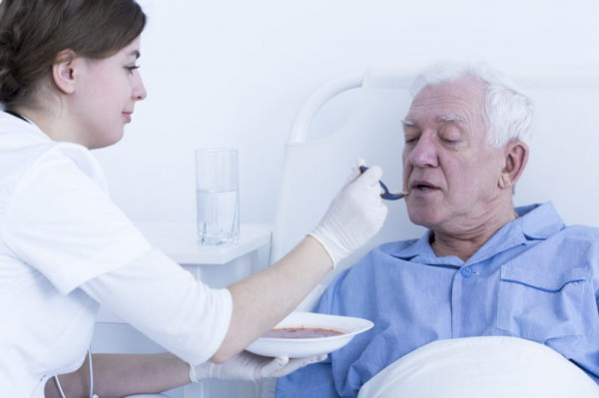
1. The project’s name: «The Path of Good»
2. Project implementation time:2 years
3. The company - applicant, offering the project:
Public health facility «Miory central district hospital»
4. Project’s objectives:
- development of the region with provision of access to medical care;
- improvement of medical and social help provided to the citizens of pension age and disabled people of Miory district, suffering from chronic illnesses and having need for medical surveillance and care;
- exercising the social protection of lonely people of pension age and disabled people, provision of medical surveillance and care, implementation the complex of disease-management therapy and methods of physical rehabilitation and other measures targeting to support the active vital activity.
5. Targets to be achieved within the frame of project implementation:
- improvement of patient nutrition management, considering specific nutrition pattern /prescription and the recommendation of doctors;
- improvement the material and technical resources of the catering department and bringing it to conformity with up-to-date requirements;
- improvement of patients’ service culture in the hospital.
6. Target group:
- citizens of pension age and disabled people of Miory district, suffering from chronic illnesses and those in need of medical surveillance and care, and who have become patients of the nursing care hospital in Disna.
7. Short description of activities within the project:
- renovation of the kitchen facility of the nursing care hospital in Disna;
- furnishing of the kitchen facility with technological equipment;
- removal of the old equipment and installation of the new one.
8. Total amount of funding (US $):25 000
Sourceoffunding | Amount of funding (US $)
Donator amounts | 20 000
Cofunding | 5 000
8. Location of the project implementation (region/district, town):
Vitebsk region, Miory district, Disna, Kuzmina St.,26
9. Contact person (full name, position, telephone, email address):
8 (02152) 51801, Head physician, Mrs. Sivaya Elena Fedorovna
miorrtmo@vitebsk.by

